CS162 ASSIGNMENT 8

NAME:

ARCHIT AGRAWAL

ROLL NO. :

202052307

SECTION:

A

**Question**

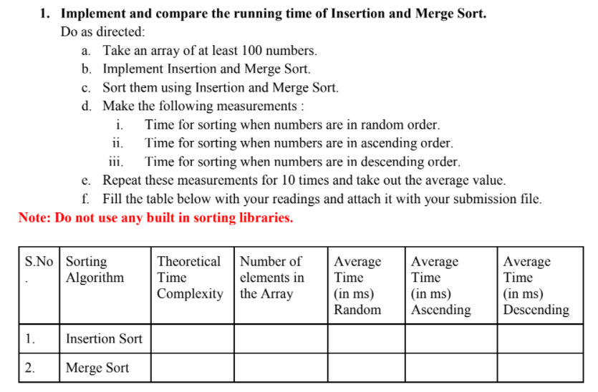

**Description -:**  The following program asks the user to input the size of array and asks to decide in what order(ascending, descending or random) the user wants to pass the array to sorting methods (insertion sort, merge sort).

The array is generated using random function, hence it is not sorted.

* If the user wants a random sorted to be passed to the sorting methods(insertion sort, merge sort), this array can directly be passed.
* If the user wants an ascending sorted array, this array will be first sorted in ascending order and then it will be passed to the sorting methods.
* If the user wants a descending sorted array, this array will be first sorted in descending order and then it will be passed to the sorting methods.

The program will calculate time taken to sort the array for both insertion and merge sort 10 times and gives the output as average time taken to do so for both the sorting methods.

***CODE***

/* This code is written to compare the average time between insertion sort and merge sort algorithms

   You will be asked to enter the size of array as input

   You will be asked to decide the order of input array

   an array will be generated randomly of that size and time will be calculated for both the algorithms (this will take place 10 times)

   the average of the time for both the methods will be calculated and printed

 */

import java.util.*;

import java.util.Random;

import java.util.Arrays;

import java.util.Collections;

public class SortingMethods{

    public static double insertionSort(Integer []arr){

        double start = System.nanoTime();

        //Insertion Sort Algorithm

        int key;

        int n = arr.length;

        for (int i = 1; i < n; i++){

            key = arr[i];

            int j = i - 1;

            while (j >= 0 && arr[j] > key){

                arr[j + 1] = arr[j];

                j = j - 1;

            }

            arr[j + 1] = key;

        }

        double end = System.nanoTime();

        return (end - start)/1000000.0;

    }

    public static void merge(Integer[] arr, int l, int m, int r){

        // sizes of two subarrays to be merged

        int s1 = m - l + 1;

        int s2 = r - m;

        int[] arr1 = new int [s1];

        int[] arr2 = new int [s2];

        int i, j;

        for (i = 0; i < s1; i++){

            arr1[i] = arr[l + i];

        }

        for (j = 0; j < s2; j++){

            arr2[j] = arr[m + 1 + j];

        }

        i = 0; j = 0;

        int k = l;

        while (i < s1 && j < s2){

            if (arr1[i] <= arr2[j]){

                arr[k] = arr1[i];

                i++;

            }

            else{

                arr[k] = arr2[j];

                j++;

            }

            k++;

        }

        while (i < s1){

            arr[k] = arr1[i];

            i++;

            k++;

        }

        while (j < s2){

            arr[k] = arr2[j];

            j++;

            k++;

        }

    }

    public static double mergeSort(Integer[] arr,int l,int r){

        double start = System.nanoTime();

        if (l < r){

            int m = (l + r)/2;

            mergeSort(arr, l, m);

            mergeSort(arr , m + 1, r);

            merge(arr, l, m, r);

        }

        double end = System.nanoTime();

        return (end - start)/1000000.0;

    }

    public static void main(String []args){

        Scanner sc = new Scanner(System.in);

        System.out.println("Enter the size of array");

        int n = sc.nextInt();

        System.out.println("1. If you want the input array to be randomly arranged, enter 1");

        System.out.println("2. If you want the input array to be arranged in increasing order, enter 2");

        System.out.println("3. If you want the input array to be arranged in descending order, enter 3");

        int order = sc.nextInt();

        double avg_time_insertion = 0.0;

        double avg_time_merge = 0.0;

        int t = 10;

        while(t > 0) {  //while loop is used to run insertion/merge sort for different arrays and compute the average.

            Integer[] a = new Integer[n];

            Integer[] b = new Integer[n]; //a copy of a[]

            Random rand = new Random();

            for (int i = 0; i < n; i++) {

                a[i] = rand.nextInt(9000) + 1000;

                //System.out.print(a[i] + " ");

            }

            for(int i = 0; i < n; i++){

                b[i] = a[i];

            }

            //a[] will be insertion sorted

            //b[] will be merge sorted

            // as random will give a new number everytime that is why

            //a copy of a[] is created to ensure that both the sorting

            //methods gets the same array

            if (order == 2) {

                Arrays.sort(a);

                Arrays.sort(b);

            } else if (order == 3) {

                Arrays.sort(a, Collections.reverseOrder());

                Arrays.sort(b, Collections.reverseOrder());

            }

            double time_in_insertion = insertionSort(a);

            double time_in_merge = mergeSort(b, 0, n - 1);

            avg_time_insertion += time_in_insertion;

            avg_time_merge += time_in_merge;

            t--;

        }

        System.out.println("*************************************************************************************************************************************************");

        System.out.printf("Average time taken in insertion sort in milliseconds : %.3f ",(avg_time_insertion/10.0));

        System.out.println();

        System.out.printf("Average time taken in merge sort milliseconds : %.3f ",(avg_time_merge/10.0));

    }

}

***OUTPUT***

* ***For random ordered input array***

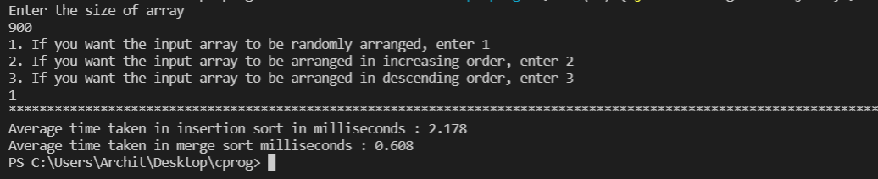

* ***For ascending ordered input array***

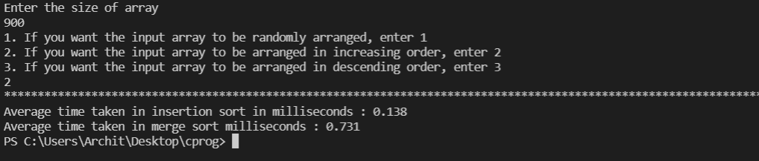

* ***For descending ordered input array***

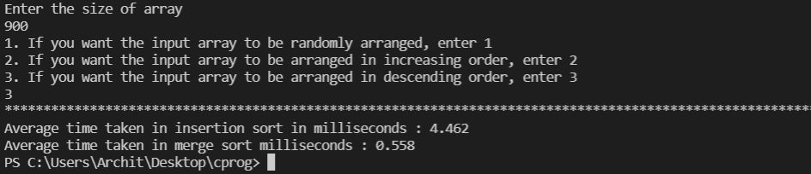

The above data is tabularized below.

|  |  |  |  |  |  |  |
| --- | --- | --- | --- | --- | --- | --- |
| S.No. | Sorting Algorithm | Theoretical Time Complexity | Number of elements in the array | Average Time (in ms) for Random Order Input | Average Time (in ms) for Ascending Order Input | Average Time (in ms) for Descending Order Input |
| 1. | Insertion Sort | $$O(n^{2})$$ | 900 | 2.178 | 0.138 | 4.462 |
| 2. | Merge Sort | $$O(n\log{n})$$ | 900 | 0.608 | 0.731 | 0.558 |